

A Course End Project Report on
College Attendance Management System

A8421- Analog Communications Laboratory

Submitted by
Batch No.

Name of the Student: A. Janani
Roll No – 25881A05CU

Course Facilitator
Mr. Ganesh Deshmukh
Assistant Professor

Department of Computer Science and Engineering
Vardhaman College of Engineering, Hyderabad
October 2025

Contents
- Introduction 3
- Literature Review 3
- Objectives 3
- Methodology 3
  - Block Diagram 3
  - Circuit Diagram and Components 3
  - Working Principle 4
  - Software Implementation 4
- Results and Discussion 4
- Mapping POs and SDGs 5
  - Program Outcomes (POs) Mapping 5
  - Sustainable Development Goals (SDGs) Mapping 5
- Conclusion 5
Bibliography 6

Abstract

The College Attendance Management System is a software application designed to simplify and automate the process of recording and managing student attendance in a college. The traditional method of maintaining attendance manually is time-consuming, requires more paperwork, and may lead to errors in attendance calculations and record maintenance.
The main objective of this project is to develop a user-friendly system that enables faculty members to record, update, and monitor student attendance efficiently. The system maintains student details, subject-wise attendance records, and attendance percentages. It also helps faculty members and administrators access attendance information easily and identify students with low attendance.
This system reduces manual work, improves accuracy, saves time, and provides better management of attendance records. It can also help students monitor their attendance status and maintain the required attendance percentage. Overall, the College Attendance Management System provides an efficient, reliable, and organized approach to managing attendance in educational institutions.

Introduction
The College Attendance Management System is a software application designed to record and manage student attendance efficiently. The traditional manual attendance system is time-consuming and may lead to errors. This system helps faculty members mark attendance, maintain student records, and calculate attendance percentages easily. It reduces paperwork, saves time, and improves the accuracy of attendance management in colleges.

Literature Review
Traditional attendance systems use paper registers to record student attendance, which is time-consuming and may lead to errors. Existing studies suggest that computerized attendance systems can improve accuracy and reduce manual work. The proposed College Attendance Management System provides an easy way to record, manage, and monitor student attendance efficiently.

Objectives
- To develop a simple and user-friendly College Attendance Management System.
- To maintain student attendance records digitally.
- To reduce manual work and paperwork.
- To calculate student attendance percentages accurately.
- To generate attendance reports easily.
- To save time and improve the efficiency of attendance management.

4 Methodology
4.1 Block Diagram

The block diagram of the College Attendance Management System consists of the following components:
- Faculty: Logs in to the system, marks student attendance, and views attendance records and reports.
- Student: Logs in to view attendance details and attendance percentage.
- Admin: Manages student and faculty details and generates reports.
- College Attendance Management System: Processes user requests, manages attendance records, and calculates attendance percentages.
- Database: Stores and retrieves student details, faculty information, and attendance records.
- Reports: Displays attendance reports, student-wise reports, subject-wise reports, and low-attendance alerts.

4.2 Working of College Attendance Management System

The College Attendance Management System provides a digital platform for recording and managing student attendance. Faculty members log in to the system and mark attendance for their classes. The attendance details are stored in the database and used to calculate each student's attendance percentage.
Students can log in to view their attendance details and monitor their attendance percentage. The administrator manages student and faculty information and generates attendance reports whenever required. The system reduces manual paperwork, minimizes errors, saves time, and improves the efficiency of attendance management in colleges.
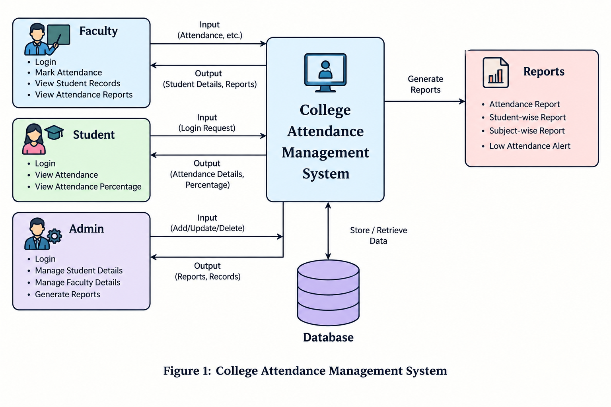

Working Principle
1. Login: Faculty, students, and administrators log in to the system using their credentials.
2. Attendance Recording: Faculty members mark student attendance, and the system stores the details in the database.
3. Attendance Calculation: The system calculates attendance percentages based on the recorded attendance.
4. Report Generation: Students can view their attendance details, and faculty or administrators can generate attendance reports easily.

Software Implementation

- Frontend: Used to develop the user interface for faculty, students, and administrators.
- Backend: Used to process attendance data and calculate attendance percentages.
- Database: Used to store student details, faculty information, and attendance records.
- Web Browser: Used to access the College Attendance Management System and view attendance reports.

Results and Discussion

The College Attendance Management System provides an efficient and user-friendly solution for managing student attendance digitally. The system allows faculty members to record attendance, maintain student details, calculate attendance percentages, and generate attendance reports easily.
By replacing the traditional manual method, the system reduces paperwork, saves time, and minimizes errors in attendance calculations. Students can check their attendance status, while administrators can manage student and faculty records effectively.
The system improves the accuracy, accessibility, and organization of attendance data. Overall, the proposed system simplifies attendance management and helps colleges maintain student attendance records in a reliable and systematic manner.

Mapping POs and SDGs

6.1 Program Outcomes (POs) Mapping

Table 1: Mapping of Program Outcomes (POs) to Project Relevance
PO No. | Program Outcome | Relevance
PO1 | Engineering Knowledge | Applied software development and database management concepts.
PO2 | Problem Analysis | Identified issues in traditional attendance recording methods.
PO3 | Design/Development of Solutions | Designed a digital attendance management system.
PO4 | Modern Tool Usage | Utilized frontend, backend, and database technologies.
PO5 | Engineer and Society | Provides an efficient solution for college attendance management.

Sustainable Development Goals (SDGs) Mapping

Table 2: Mapping of Sustainable Development Goals (SDGs) to Project Relevance
SDG No. | Goal | Relevance
SDG 4 | Quality Education | Supports efficient student attendance monitoring in educational institutions.
SDG 9 | Industry, Innovation, and Infrastructure | Promotes digital innovation in college administration.
SDG 12 | Responsible Consumption and Production | Reduces paper usage by replacing manual attendance registers with digital records.

Conclusion

The College Attendance Management System provides a simple and efficient solution for recording and managing student attendance digitally. It reduces manual work, minimizes errors, saves time, and decreases paper usage. The system helps faculty members maintain attendance records, calculate attendance percentages, and generate reports easily. Students can also monitor their attendance status, while administrators can manage student information effectively. Overall, this project improves the accuracy, reliability, and efficiency of attendance management in educational institutions.

Bibliography

[1] Y. K. Kumawat, V. Bairwa, R. K. Dhawan, V. Vivek, and N. Kaushik, “Design and
Implementation of a Web-Based Attendance Management System for Academic
Institutions,” International Journal of Creative Research Thoughts, vol. 12, no. 4, pp.
o760–o763,2024.<Link
url="https://ijcrt.org/viewpaperforall.php?paper=IJCRT24A4698" title="Paper link"/>.

[2] M. Zhao, G. Zhao, and M. Qu, “College Smart Classroom Attendance Management
System Based on Internet of Things,” Computational Intelligence and Neuroscience, vol.
2022, Article ID 4953721, 2022. <Link url="https://doi.org/10.1155/2022/4953721"
title="Paper link"/>.

[3] S. M. El-Salhi, S. N. Al-Haj Saleh, and I. I. Al-Amro, “Towards Developing an
Automated Attendance Management System Using Barcode Reader: Hashemite
University as a Case Study,” International Journal of Business Information Systems, vol.
31, no. 1, pp. 69–85, 2019. <Link url="https://doi.org/10.1504/IJBIS.2019.099527"
title="Paper link"/>.

[4] I. Ngonadi and S. Ajiroghene, “Class-Based Digital Attendance Management System
with Computer Vision,” INTI Journal, 2022. <Link
url="https://iuojs.intimal.edu.my/index.php/intijournal/article/view/165" title="Paper
link"/>.

[5] R. Deshpande and S. Nikam, “CampusConnect—Design and Development of an
Automated Attendance Management System,” International Journal of Computer
Applications, vol. 187, no. 79, pp. 39–42, 2026. <Link
url="https://ijcaonline.net/archives/volume187/issue79/campusconnect-design-and-development-of-an-automated-attendance-management-system/" title="Paper link"/>.

[6] S. Langde, A. Maurya, T. Nakhawa, A. Sinha, S. Patil, K. Karanam, and H. Mugutrao,
“Automated Attendance System,” International Journal of Applied Research, vol. 4, no.
10, pp. 248–257, 2018. <Link
url="https://www.allresearchjournal.com/archives/2018/vol4issue10/PartD/4-10-40-294.pdf" title="Paper link"/>.

